
ENERGY EXERCISE
STEP 1 - Materials
You will need 2 x metal coat hangers, 1 pliers or wire cutter tool, 2 plastic drinking straws.
It should take no more than 10 minutes to make.
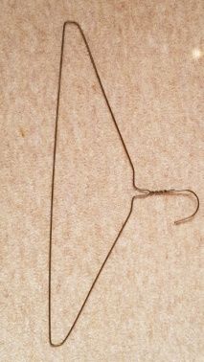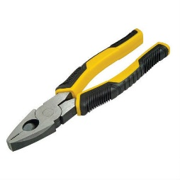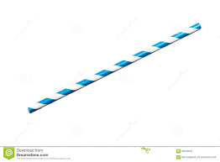
STEP 2 - Cutting the rod shape
- Taking the wire cutter or pliers, make a cut about 2 thirds of the way along the bottom of the hanger and another cut halfway up the side so that you are left with an “L” shape.
- Measure against your second hanger to ensure you have equal lengths and cut in the same way.

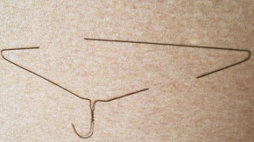

STEP 3 - Creating the handle
- Cut the drinking straw to the length of the smaller end of the “L” shape.
- This will form the “handle” of your Energy rod and the straw will allow the rod to move freely without the influence of your hands.
